Dataset
rnd_room_c3_05:
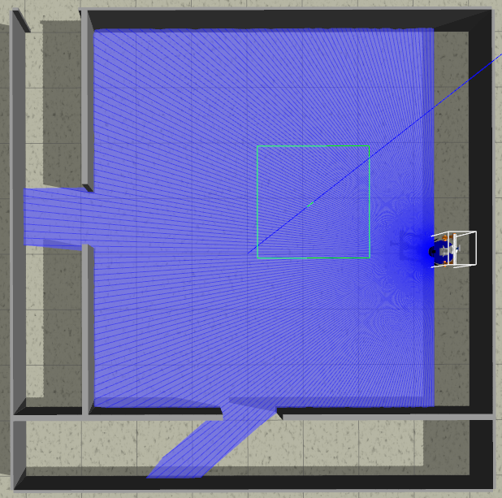
samples
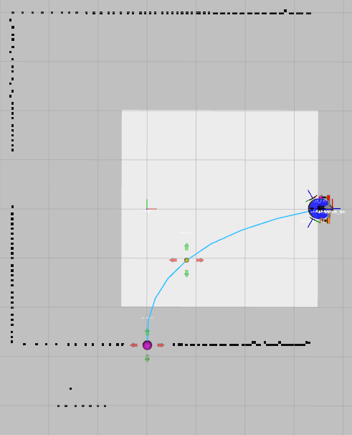
1)
cuarto A a pasillo inf (x4) HEAD tilt: -0.4
files: data_from_path_2025-02-28_17-12-04 to data_from_path_2025-02-28_17-13-11

2)
cuarto A a pasillo inf (x4) HEAD tilt: -0.6
files: data_from_path_2025-02-28_17-15-47 to data_from_path_2025-02-28_17-17-13

3)
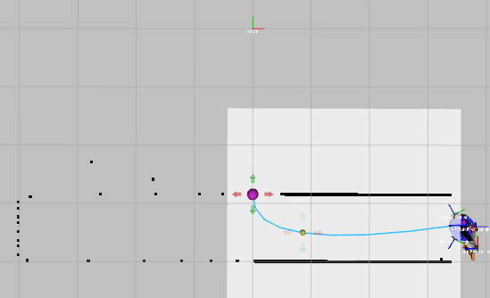
pasilo der a puerta (x4) (3.6 -3.4 -1.57075) HEAD tilt: -0.4
files: data_from_path_2025-02-28_17-39-16 to data_from_path_2025-02-28_17-39-16

4)
pasilo der a puerta (x4) (3.6 -3.4 -1.57075) HEAD tilt: -0.6
files: data_from_path_2025-02-28_17-41-15 to data_from_path_2025-02-28_17-42-06

5)
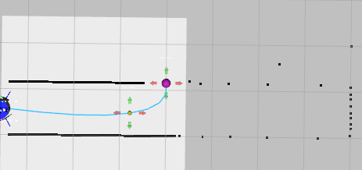
pasilo izq a puerta (x4) (-3.6 -3.4 0) HEAD tilt: -0.4
files: data_from_path_2025-02-28_17-44-38 to data_from_path_2025-02-28_17-45-32

6)
pasilo izq a puerta (x4) (-3.6 -3.4 0) HEAD tilt: -0.6
files: data_from_path_2025-02-28_17-46-33 to data_from_path_2025-02-28_17-47-24

7)
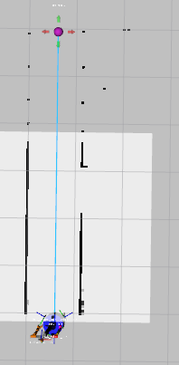
pasillo a salida (x4) (-3.4 -2.2 1.57075) HEAD tilt: -0.4
files: data_from_path_2025-02-28_17-52-52 to data_from_path_2025-02-28_17-53-46

8)
pasillo a salida (x4) (-3.4 -2.2 1.57075) HEAD tilt: -0.6
files: data_from_path_2025-02-28_17-54-33 to data_from_path_2025-02-28_17-55-28

-----
Mirror
-----
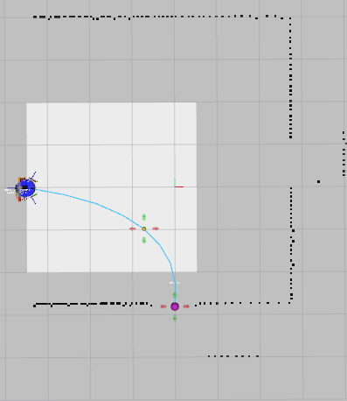
9)
cuarto A a pasillo inf (x4) HEAD tilt: -0.4
files: data_from_path_2025-02-28_18-03-15 to data_from_path_2025-02-28_18-04-08

10)
cuarto A a pasillo inf (x4) HEAD tilt: -0.6
files: data_from_path_2025-02-28_18-05-20 to data_from_path_2025-02-28_18-06-12

11)
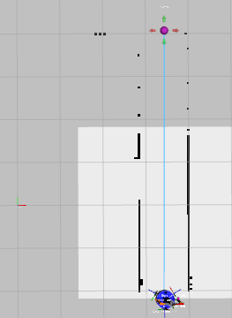
pasillo a salida (x4) (3.4 -2.2 1.57075) (-3.5 3.1 -1.57075) HEAD tilt: -0.6
files: data_from_path_2025-02-28_18-10-36 to data_from_path_2025-02-28_18-11-32

12)
pasillo a salida (x4) (3.4 -2.2 1.57075) (-3.5 3.1 -1.57075) HEAD tilt: -0.4
files: data_from_path_2025-02-28_18-12-29 to data_from_path_2025-02-28_18-13-23

